**Leerstof Genetica 1 BFV (code BFVH3GEN1) 2021-2022**

Boek: Concepts of genetics, 12e (global) editie (2020), Klug et al.

Slides: Behorend bij de colleges, gelinked aan de lesstof uit het boek

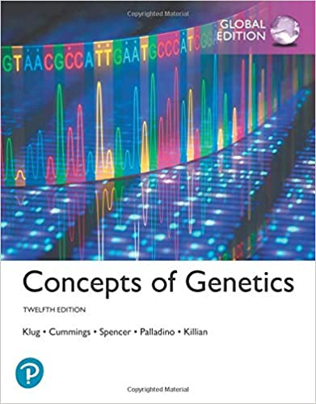 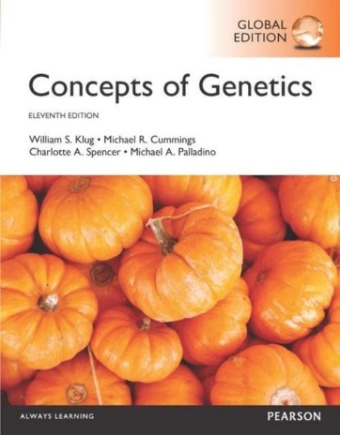

12e global editie 11e editie

Tabel 1: leerstof uit het boek 12e editie

|  |  |  |
| --- | --- | --- |
| Hoofdstuk | Paragrafen | # blz. ~ |
| 10 DNA structure and analysis | 1, 5, 6, 7, 9, 10 | 12 |
| 11 DNA replication and recombination | 1 (alleen blz 277), 2, 3, 4, 6, 7 | 15 |
| 12 DNA organization in chromosomes | Alle | 16 |
| 13 The genetic code and transcription | Alle, behalve 12 | 23 |
| 14 Translation and proteins | 1, 2, 4, 8, 9, 10, 11 | 17 |
| 15 Gene mutation, DNA repair and transposition | Alle | 29 |
| 16 Regulation of gene expression in prokaryotes | Alle | 16 |
| 17 Transcriptional regulation in eukaryotes | Alle | 16 |
| 18 Posttranscriptional regulation in eukaryotes | 1, 3, 5 | 13 |
| 24 Cancer and regulation of the cell cycle | Alle | 16 |

**Wat eventueel ook gebruikt kan worden:**

Boek: Concepts of genetics, 11e (global) editie (2016), Klug et al.

Slides: Behorend bij de colleges, gelinked aan de lesstof uit het boek

Tabel 2: leerstof uit het boek 11e editie

|  |  |  |
| --- | --- | --- |
| Hoofdstuk | Paragrafen | # blz. |
| 10 DNA structure and analysis | 1, 5, 6, 7, 9, 10 | 17 |
| 11 DNA replication and recombination | 1 (alleen blz 296), 2, 3, 4, 6, 7 | 14 |
| 12 DNA organization in chromosomes | Alle | 16 |
| 13 The genetic code and transcription | Alle | 24 |
| 14 Translation and proteins | 1, 2, 4, 9, 10, 11, 12 | 17 |
| 15 Gene mutation, DNA repair and transposition | Alle | 23 |
| 16 Regulation of gene expression in prokaryotes | Alle | 16 |
| 17 Regulation of gene expression in eukaryotes | Alle | 23 |
| 19 Cancer and regulation of the cell cycle | Alle | 16 |